Jordan Batchelor
August 6, 2024
Arizona Violent Death Reporting System: Methods for Exploring Written Narratives
the center for violence prevention and community safety, arizona state university


About the Center for Violence Prevention and Community Safety
To become more committed to the Arizona community and to society as a whole, Arizona State University is setting a new standard for research universities through the model of the New American University. As a New American University, ASU is measured not by whom we exclude but by whom we include and by our pursuit of research that considers the public good; we assume major responsibility for the economic, social, and cultural vitality of our community.

Social embeddedness is core to the development of ASU as the New American University. Social embeddedness is a university-wide, interactive, and mutually supportive partnership with the communities of Arizona. Toward the goal of social embeddedness, Arizona State University established the Center for Violence Prevention and Community Safety in July 2005 to respond to the growing need of Arizona’s communities to improve the public’s safety and well-being. The Center for Violence Prevention and Community Safety is a research unit within the Watts Family College of Public Service and Community Solutions at Arizona State University.

The Center’s mission is to generate, share, and apply quality research and knowledge to create “best practice” standards. The center specifically evaluates policies and programs; analyzes and evaluates patterns and causes of violence; develops strategies and programs; develops a clearinghouse of research reports and “best practice” models; educates, trains, and provides technical assistance; and facilitates the development and construction of databases. For more information about the Center for Violence Prevention and Community Safety, please contact us using the information provided below.

Suggested citation
Batchelor, J. (2024). Arizona Violent Death Reporting System: Methods for Exploring Written Narratives. Center for Violence Prevention and Community Safety, Arizona State University.
Mailing Address and contact information
Center for Violence Prevention and Community Safety Arizona
State University
411 N. Central Ave.
Suite 680
Mail Code 3120
Phoenix, AZ 85004

Phone: (602) 496-1425
Website: azvdrs.org

INTRODUCTION
The National Violent Death Reporting System (NVDRS) is a state-based surveillance tool to improve our understanding of violent deaths and is sponsored by the Centers for Disease Control and Prevention (CDC). Given the magnitude of the violent death problem in the United States, improved data collection and research efforts are critical to finding and implementing better intervention and prevention efforts. All 50 states, Puerto Rico, and the District of Columbia participate in the NVDRS. Arizona began its partnership in the surveillance system in 2015. Through data integration and abstraction from death certificates, medical examiner reports, and law enforcement
reports, the Arizona Violent Death Reporting System (AZ-VDRS), as an NVDRS site, seeks to contribute to efforts to reduce violent deaths in Arizona.

All violent deaths in the AZ-VDRS include up to two written narratives that summarize pertinent information about the circumstances surrounding the death. One narrative is written based on coroner/medical examiner (CME) reports and the other on law enforcement (LE) reports. To make use of these narratives, researchers can employ several different methods. This report describes a transparent and reproducible framework that makes use of word frequency, word co-occurrences, and key words, among other tools, to gain insight into the content and meaning of texts. Below, we illustrate how these methods work by applying them to CME and LE narratives from the AZ-VDRS. Specifically, we focus on two research questions:

- In what ways do the contents of CME and LE narratives differ?
- In what ways do the contents of LE narratives written about male decedents differ from those written about female decedents?

Data and Methods
We considered only violent deaths occurring between 2015 and 2022, the years for which AZ-VDRS data collection is complete. We then focused only on suicides, as language likely varies by violent death and suicide is the most prevalent in the dataset. This resulted in an initial dataset of 11,244 victims, which was further reduced to include only incidents for which circumstances were known and narratives contained at least 31 words. The final dataset included 10,258 CME narratives and 8,504 LE narratives. CME narratives were 213 words on average (SD = 96.6), and LE narratives were 279.7 words on average (SD = 196). Thus, LE narratives were longer but also showed greater variation.
This analysis begins by examining the most frequent words across the corpora (Exhibit 1). Instead of showing the most frequent words overall, Exhibit 1 displays the 10 most frequent words in either corpus by part-of-speech, specifically adjectives, adverbs, nouns, and verbs. As lexical word classes, these words carry semantic content. For example, adjectives can describe qualities; adverbs can describe time, place, and manner; nouns can describe things; and verbs can describe mental and physical activities or abstract relations.

Exhibit 1
Top 10 most frequent words by word class and narrative source

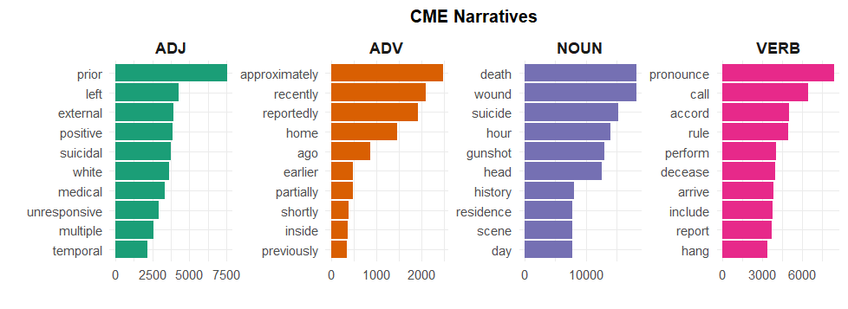

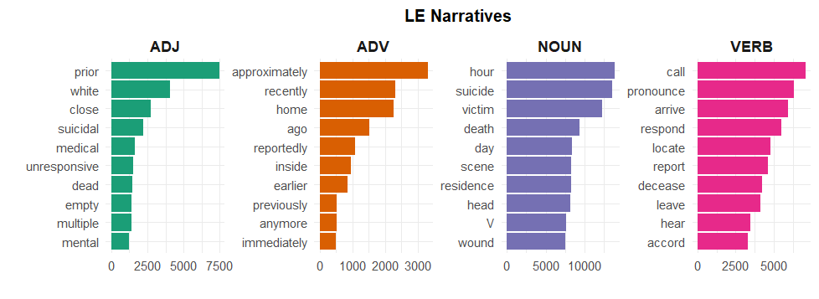

Exhibit 1 suggests that the narratives rely on different words and word classes. CME narratives rely to a greater extent on nouns and adjectives, while LE narratives use more verbs and adverbs. For example, CME narratives show six different nouns that occur more than 10,000 times, compared to three nouns in the LE narratives. On the other hand, LE narratives show four verbs that occur at least 5,000 times compared to only two in CME narratives. Among the specific word choices, the top adverbs in both narratives are similar, serving to describe time (recently, ago), place (home, inside), and imprecision (approximately). Similarly, both narratives frequently use verbs of communication (pronounce, call), but LE narratives use more verbs referring to the arrival of law enforcement at the scene of the suicide (arrive, respond). In general, top words across the narratives suggest that CME narratives put greater emphasis on detailing the victim’s wounds, while LE narratives put greater emphasis on information gathered from the scene of the suicide, such as witness accounts.
That LE narratives often reference people other than first responders is corroborated by a keyword analysis, a data-driven method for identifying the distinct words of one dataset relative to another. We took the LE narratives as the target corpus and CME narratives as the reference corpus, resulting in 5,070 keywords. We sorted the list by effect size and reviewed the top 100 keywords for thematic patterns, four of which are shown in Exhibit 2.

Exhibit 2
Four thematic categories drawn from the top 100 keywords of a keyword analysis
First responders
officers, dispatched, investigated, regards, dispatch
*Example: Law enforcement was dispatched to the scene.
Involved parties
IP1, CP1, witness, CP2, RP1
Example: The witness reported seeing the victim a little over a week prior.
Communication
interviewed, advised, explained, recalled, reiterated
Example: The neighbor explained that the firearm belonged to him.
Behavior
yelling, crying, screaming, hysterical, shocked
Example: A friend said the V was hysterical the last time they had met.
* Example sentences are fictionalized to protect the privacy of the decedents

These four categories reflect that LE narratives are based on reports written by first responders, specifically, law enforcement, who are often present at the scene of the violent death. However, the observations gleaned by other parties interviewed at the scene prove insightful. A primary difference between LE and CME narratives, then, is the greater space in LE narratives devoted to recording what involved parties observe, think, or know about the victim, and accessing these stretches of text is key to making the most out of LE narratives.
Next, we split the LE narratives into a sub-corpus of narratives about male victims (n = 6,639) and a sub-corpus of narratives about female victims (n = 1,865). We run two more keyword analyses, one with the female narratives as the target corpus and another with the male narratives as the target corpus. Exhibit 3 displays five thematic categories identified from a review of the top 200 keywords in either analysis.

Exhibit 3
Five thematic categories drawn from the top 200 keywords from two keyword analyses
Target corpus: Female |  | Target corpus: Male
Label | Top five keywords | Label | Top five keywords
Drugs for mental health problems | benzodiazepines, amitriptyline, doxepin, bupropion, fluoxetine | Firearm | .223, hammer, armed, .330, Walther
Drugs for physical health problems | topiramate, carisoprodol, diphenhydramine, Tylenol | Legal problems | detention, incarcerated, felony, violation, parole
Journaling and notes | forgiveness, spiral, journal, write, dear | Recreational drug, tobacco, and alcohol use | heavy, vape, drinker, THC, tobacco
Method of suicide | overdose, fabric, fumes, rail, knot | Location | public, sidewalk, forest, lawn, commercial
Mental health of victim | borderline, personality, breakdown, therapist, struggles | Physical health of victim | prostate, bladder, pacemaker, emphysema, recover

A large proportion of the keywords relate to drugs and medication for females and to firearms for the males, reflecting differences between in method of suicide. For example, the female column in Exhibit 3 has the category Method for suicide, which includes language referring to medication poisoning (overdose), hanging (fabric, rail), and carbon monoxide poisoning (fumes). These words were not key in the male narratives, though notable categories for males included legal (detention, incarcerated) and financial (debt, owed) issues, recreational drug, tobacco, and alcohol use (heavy, vape), and language indexing location of suicide, especially outside of one’s home (public, sidewalk).

Conclusion and Summary
This report aimed to provide a brief illustration of a framework for analyzing the written narratives of the AZ-VDRS, focusing on suicides that occurred between 2015 and 2022. We sought to identify differences between CME and LE narratives to gain insight into what each narrative type may have to offer researchers. LE narratives were longer on average and included more language referring to non-law enforcement persons at the scene of violent deaths. By contrast, CME narratives put greater emphasis on descriptions of wounds sustained by decedents. Given that researchers often select either CME or LE narratives as their data, they should take into account the focuses of either narrative type and select the narrative that best matches their research questions.

We also investigated differences in LE narratives written for male and female suicide decedents. The most significant differences pertained to the method of suicide. Narratives written for males included a range of words referencing firearms and suicide by firearms, while narratives written for females included a range of words referencing medication and medication overdose. While both narratives mentioned physical health problems, the specific issues differed by sex. Moreover, mental health problems, including references to mental health professionals, were more prevalent in the female narratives. Male decedents also included more language pertaining to non-health-related issues, such as financial and legal problems.

Analyses of AZ-VDRS narratives—or narratives from any participating state’s surveillance system—should be compared against the other, non-text-based variables collected for NVDRS. The primary goal should be to develop approaches that can systematically highlight information in narratives that are not already coded for in those other variables, thereby extracting the unique insights of narratives that may be useful for prevention and policy efforts.

